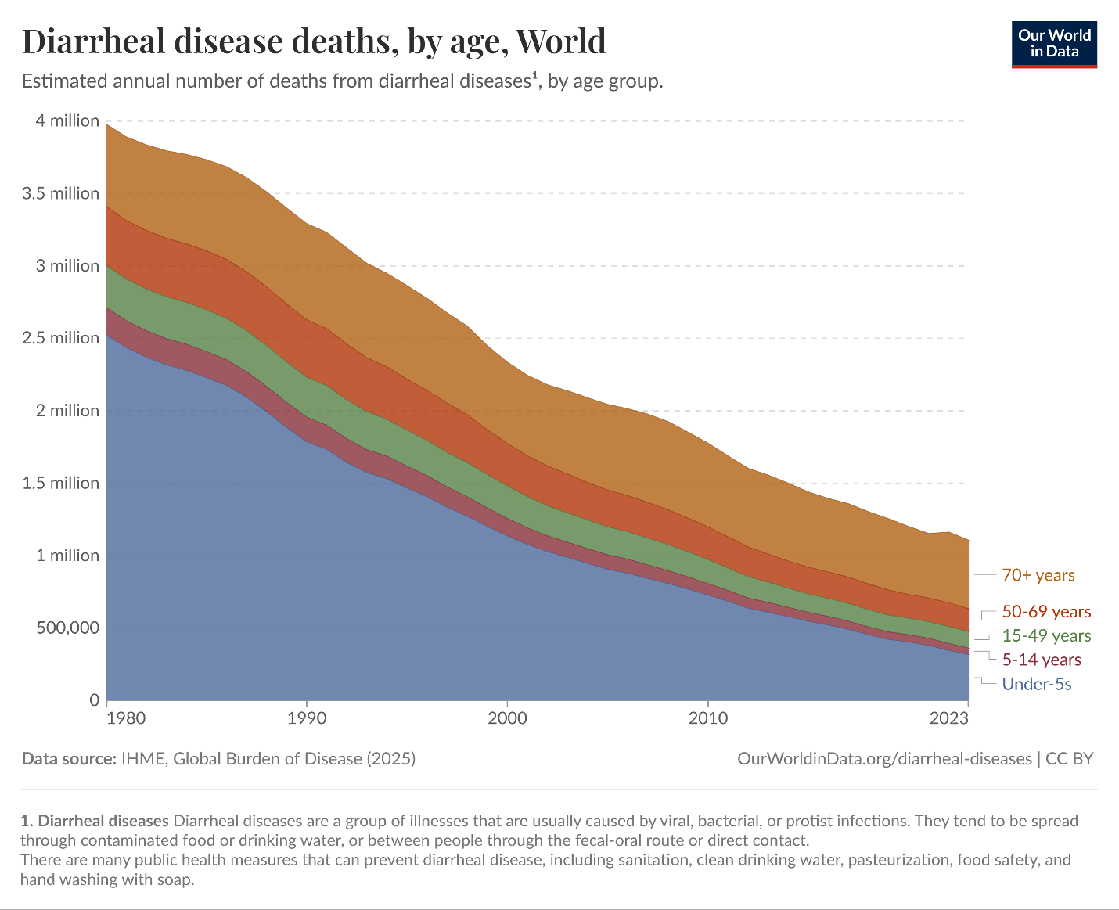

1. Main visualization goal and audience
The chart targets a broad, non-specialist public audience — the kind reached by Our World in Data's mission of making global development data accessible. The goal is explicitly communicative: to show, at a glance, that global deaths from diarrheal diseases have fallen dramatically over four decades, and that children under 5 were historically the dominant victims but that reduction has been the greatest success story. The stacked area form prioritizes emotional impact (the collapsing blue mass) over precise readout of individual values.

2. Visualization Dimensions Using Alberto Cairo's Visualization Wheel
The visualization "Diarrheal Disease Deaths, by Age, World" can be analyzed using Alberto Cairo's Visualization Wheel, which evaluates the balance between opposing design dimensions
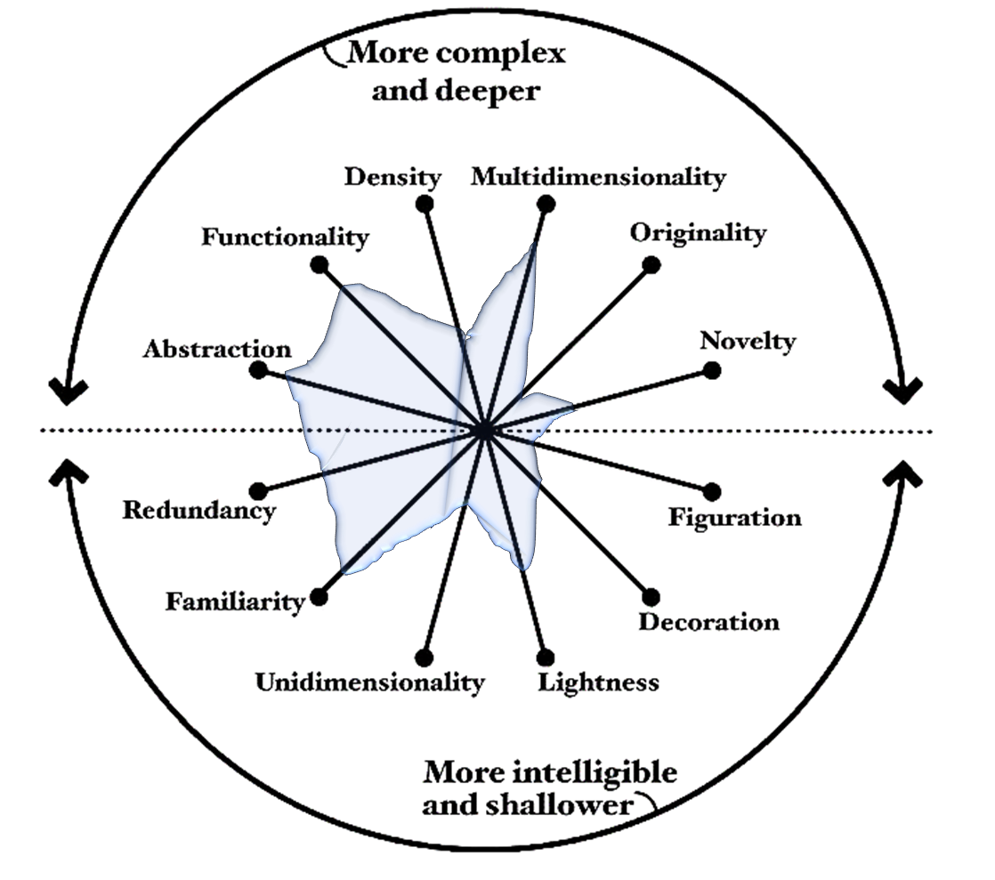

Dimension Pair | Assessment
Abstraction vs. Figuration | 95% Abstraction – 5% Figuration
Functionality vs. Decoration | 90% Functionality – 10% Decoration
Density vs. Lightness | 40% Density – 60% Lightness
Multidimensionality vs. Unidimensionality | 70% Multidimensionality – 30% Unidimensionality
Originality vs. Familiarity | 20% Originality – 80% Familiarity
Novelty vs. Redundancy | 30% Novelty – 70% Redundancy

The chart strongly favors abstraction because it uses a statistical representation rather than pictorial elements. It is highly functional, as nearly all graphical elements contribute to communicating the data. The design leans toward lightness, presenting a large amount of information without overwhelming the reader. It is moderately multidimensional, displaying mortality counts, age groups, and temporal changes simultaneously. The visualization is highly familiar, employing a standard stacked area chart that most readers can easily understand. Finally, it contains a degree of redundancy through labels, colors, and ordering that reinforce comprehension.

3. Main Drawbacks Following Alberto Cairo and Edward Tufte's Principles
Although the visualization is effective, several limitations can be identified based on the recommendations of Alberto Cairo and Edward Tufte.
- Difficult disaggregation: Stacked areas make it nearly impossible to read the absolute values of middle layers (50–69 years, 15–49 years) accurately, since their baseline shifts with the layer below. The reader can see trends but not values. Cairo would flag this as a trade-off between the "whole picture" and individual accuracy.
- Color accessibility: The palette — a brownish orange, a warm orange-red, a muted green, a muted pink, and a steel blue — does not follow colorblind-safe conventions. The 5–14 and 15–49 bands (pink and green) are particularly hard to distinguish for deuteranopic viewers, violating Cairo's principle of accessibility.
- No reference lines or annotations: The chart misses opportunities to mark key events that would transform a trend chart into an insight chart, which Cairo would consider a missed step toward enlightenment.
- Limited Exploration: The visualization is primarily explanatory rather than exploratory. Users can identify the main message—the decline in diarrheal disease deaths—but have limited opportunities to investigate detailed patterns or relationships. trends
Edward Tufte would focus on data-ink ratio and graphical integrity:
- The stacked form inflates visual complexity: Tufte generally prefers small multiples over stacking, because each area's shape is distorted by the layers beneath it. A panel-per-age-group would preserve each individual trend more honestly.
- Lie factor / perceptual distortion: The area of the under-5 band visually dominates (it is the bottom, widest band with a stable baseline), which correctly reflects the data. But the upper bands appear to show almost no change because their relative share of a shrinking total remains roughly constant. This can mislead a reader into thinking, say, deaths among 50–69-year-olds barely changed, when in absolute terms they also fell substantially before 2010.
- Good data-ink ratio overall: Tufte would approve of the absence of gridline clutter, the use of dashed horizontal guides at meaningful values, and the clean typography.
- Redundant legend: The legend sits outside the chart area rather than directly labeling the bands. Tufte strongly prefers direct labeling inside the chart, which would eliminate the eye-travel between legend and bands.

4. Graphical Variables Used and Their Suitability
According to Bertin's graphical variables, the visualization employs several visual encoding techniques.
Graphical Variable | Usage | Suitability
Position (X-axis) | Represents years from 1980 to 2023 | Highly suitable because time series are best represented spatially along a horizontal axis.
Position (Y-axis) | Represents annual number of deaths | Highly suitable because position is one of the most accurate visual channels for quantitative data.
Color(Value/lightness) | Not used systematically | The warm-to-cool ordering of hues implies a vague age sequence (blue = youngest, orange = oldest), which is intuitive but not explicit
Color Hue | Differentiates age groups | Suitable because distinct colors help identify categories.
Length/Height | Indicates changes in mortality levels over time | Suitable and easy to perceive for the bottom layer.
Ordering | Age groups are stacked consistently across time | Suitable because it supports pattern recognition and trend tracking.
Overall Evaluation of Graphical Variables
The most effective graphical variables used are position and color, which clearly communicate trends and categorical distinctions. The use of area is appropriate for showing contributions to the total number of deaths but is less effective for precise comparisons among age groups. Consequently, while the stacked area chart successfully communicates the overall decline in diarrheal disease mortality, a grouped line chart or multiple small-multiple charts could improve detailed comparisons between age groups.

